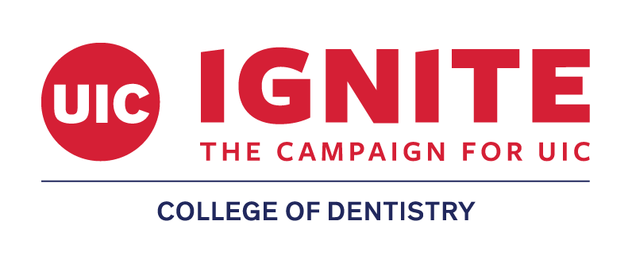
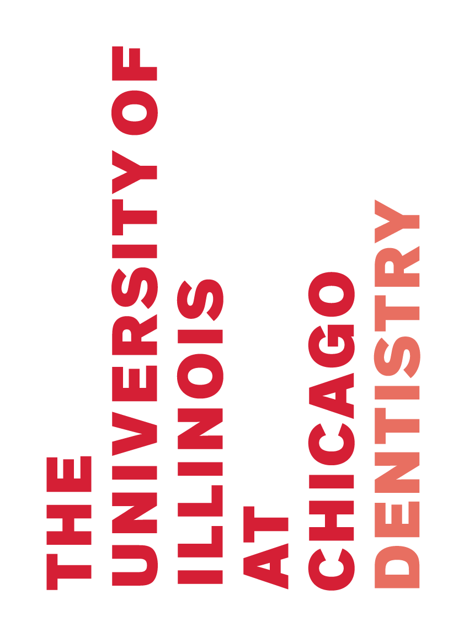
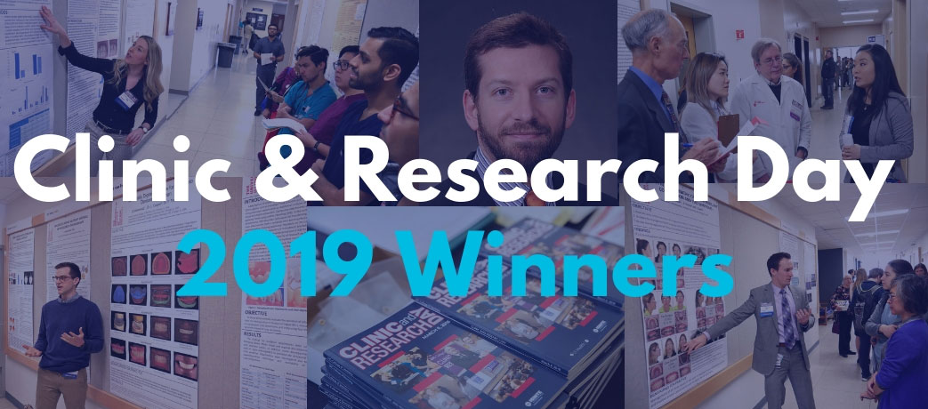
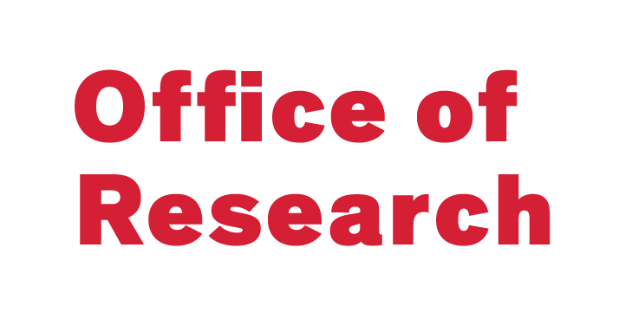
UIC College of Dentistry's annual Clinic & Research Day provides a forum for students, postgrads, and research staff to present research achievements to the members of the College and larger research community. Additionally, Clinic and Research Day offers continuing education credit opportunities, dental products and service exhibits, a keynote lecture, and student awards. Research at the College of Dentistry spans from “bench to chairside” to advance diagnostic and interventional knowledge and therapies in oral health and other fields.
Driving life-changing discoveries through research is one of the goals of the University’s IGNITE: The Campaign for UIC, its $37 million fundraising campaign.
Research Themes

 | Craniofacial Pathobiology  Working to improve treatment of oral cancer, caries, periodontal and other oral diseases. |  | Clinical, Translational & Community  Leading transformative studies to improve oral health outcomes in the clinic and community.
Regenerative Science
Moving beyond tissue replacement, using materials to enable our bodies to regenerate damaged and failing tissues.

Over 100 posters covering several topics:
- Cancer Biology/Oral Cancer
- Biomaterials/Dental Materials
- Tooth Development & Movement
- Social Science/Behavior
- Wound Healing/Tissue Regeneration & Repair
- Imaging &Therapeutic Modalities
- Case Reports & Literature Reviews

Tours and exhibits
- Vendor exhibits throughout the day.
- Visit the Kottemann Gallery of Dentistry and the DuBrul Archives Room.
- Tour the clinics and laboratories.

Learn more about Clinic & Research Day by visiting
dentistry.uic.edu/research/clinic-and-research-day

Keynote Speaker

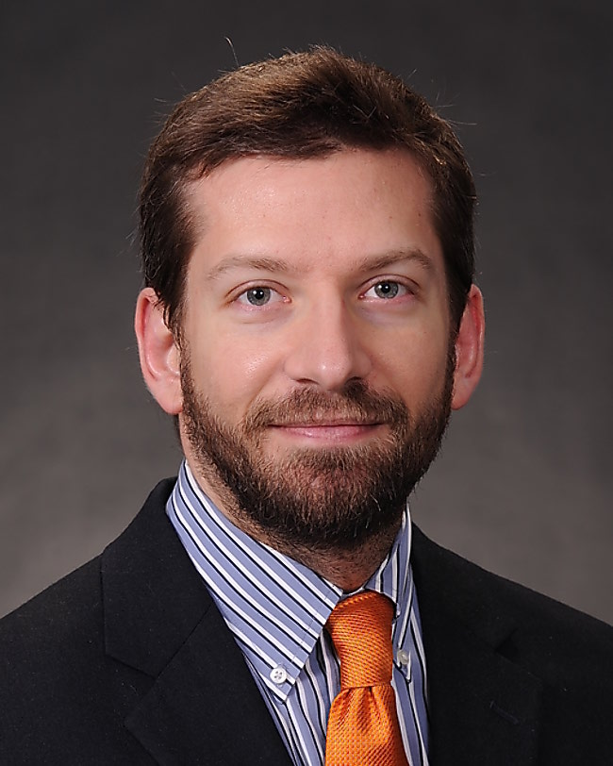
Kimon Divaris, DDS, PhD
Associate Professor, Department of Pediatric Dentistry
UNC School of Dentistry
Department of Epidemiology, Gillings School of Global Public Health, University of North Carolina

Topic: “Scientific Advances Transforming Dentistry Towards Precision Oral Health and Care”
Dr. Divaris’s research focus is on proximal and distal determinants of oral health and disease, ranging from genomics of oral health traits and behavioral sciences to health disparities and dental education.

Sponsored by Dentsply Sirona

2019 Clinic and Research Day Awards

Award | Category | Presenter | Principle Mentor | Poster #
Illinois State Dental Foundation | Best Basic/Basic Translational Science: Dental Student | Joseph Schlosser | Dr. George | 550
Illinois State Dental Foundation | Best Clinical/Clinical Translational Science: Dental Student | Lily Lou | Dr. Atsawasuwan | 403
Illinois State Dental Foundation | Best Public Health Science: Dental Student | Alexandria Rozgony | Dr. Caplin | 434
OKU Sigma Chapter | Best Basic/Basic Translational Science: Dental Student | Joseph Schlosser | Dr. George | 550
OKU Sigma Chapter | Best Clinical/Clinical Translational/Population Health Sciences: Dental Student | Lily Lou | Dr. Atsawasuwan | 403
UI Cancer Center | 1st Place | Hetal Patel | Dr. Le Hew | 566
UI Cancer Center | 2nd Place | Brian Cherny | Dr. Schwartz | 567
UI Cancer Center | 3rd Place | Harshleen Kaur | Dr. Radosevich | 562
Literature Review | Best Undergraduate | Elizabeth Mansoori | Dr. Sukotjo | 416
Literature Review | Best Resident Fellow | Deric Truskoski | Dr. Nicholas | 402
Case Report | Best Dental Student | Stephanie Bollow | Dr. Alapati | 502
Case Report | Best Resident Fellow | Helen Yang | Dr. Bahcall | 503
Basic/Basic Translational Science | Best Undergraduate (tie) | Susana Peszek  Jessica Stacko | Dr. Bedran-Russo  Dr. Reed | 540  522
Basic/Basic Translational Science | Best Dental Student (tie) | Yasmin Obaidi Bakir  Medalith Somers | Dr. Bedran-Russo  Dr. Bedran-Russo | 541  542
Basic/Basic Translational Science | Best Resident Fellow (tie) | Edward Song  Varun Kulkarni | Dr. Xie  Dr. Nares | 509  529
Basic/Basic Translational Science | Best Graduate Student | Elizabeth Guirado | Dr. George | 543
Basic/Basic Translational Science | Best Post-Doctoral Fellow | Mariana Cavalcante dos Reis | Dr. Bedran-Russo | 544
Clinical/Clinical Translational Science | Best Dental Student | Lily Lu | Dr. Atsawasuwan | 403
Clinical/Clinical Translational Science | Best Resident Fellow | Angelo Arce | Dr. Kratunova | 518
Population Health Science | Best Undergraduate | Hetal Patel | Dr. Le Hew | 556
Population Health Science | Best Dental Student | Alexandria Rozgony | Dr. Caplin | 434
Population Health Science | Best Resident Fellow | Benjamin Palla | Dr. Miloro | 539
SCADA 2020 | 1-3yr DMD/1-2yr DMDAS Clinical/Population Health | Alexandria Rozgony | Dr. Caplin | 434
Hinman Student Research Symposium | Best Basic/Basic Translational Science  Dental Student (tie) | Yasmin Obaidi Bakir  Medalith Somers | Dr. Bedran-Russo  Dr. Bedran-Russo | 541  542

Additional recognition goes to Joseph Schlosser and Amir Akhras for being the 2018 Isaac Schour Research Scholars

